Milestone 1: Login and Registration Form
Samantha Krall
CST-236
April 2019
ER Diagram:
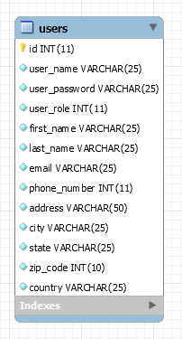
Wireframe:
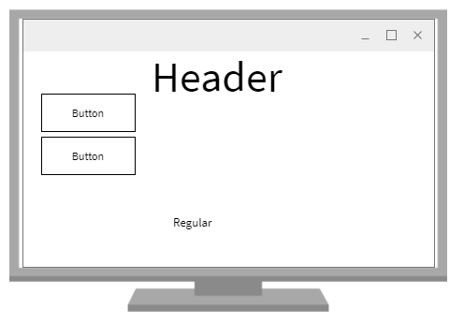 Index page, nothing selected
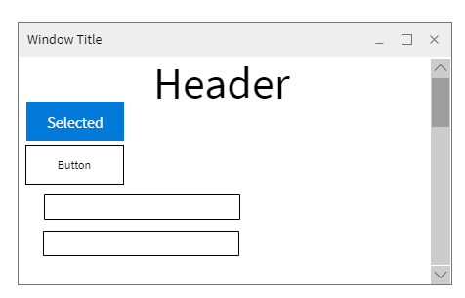Login selected
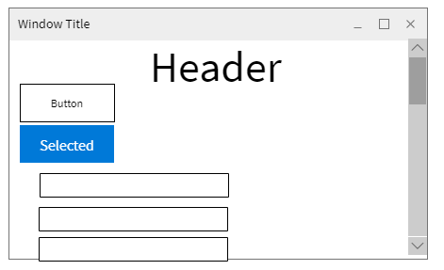Register selected
Video:
https://youtu.be/3IcU4wTCEK8

